Architecture & contracts
Oct 18, 2026 · @Ravin
One Next.js app serves the workspace and the customer portal, one API owns every rule, one Postgres with row-level security holds every workspace, and everything external (payments, email, messaging, AI) sits behind an adapter with a standalone fallback. This tab is the spec AI agents build from; the Data model section of Design inputs defines the entities it refers to.

System architecture
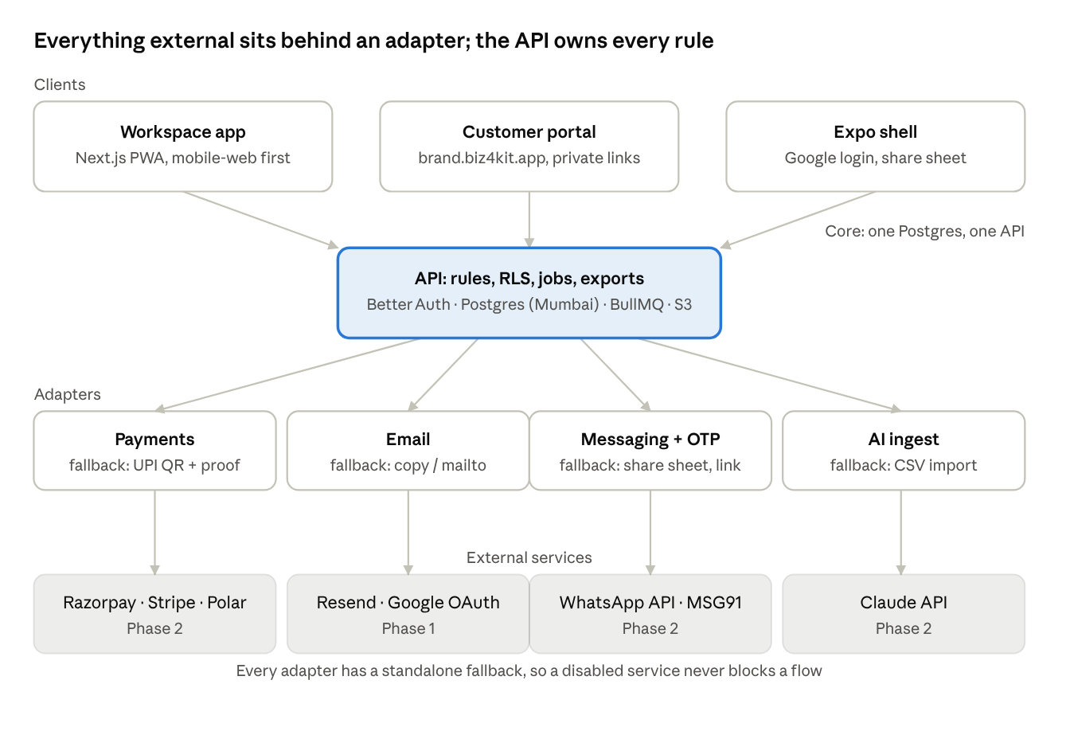
system architecture · 3 clients, 1 core, 4 adapters, external services by phase
Clients never talk to an external service directly; every call goes through the API and then an adapter, so a missing or disabled connector always lands on the Phase 1 fallback. In Phase 1 only the email adapter and Google OAuth have a real provider behind them.

Services and modules
One deployable API, split into modules with an owner each; a module may only call another through its exported service, never its tables.
Module | Owns | Exposes | Owner (fill in)
auth | Better Auth config, sessions, invites, roles, re-auth | requireUser, requireRole, invite service
workspace | Workspace, Member, brand theme generation, numbering settings | theme tokens, numbering allocator
catalog | CatalogItem, Package, CSV import, public catalog read model | item and package services, public page data
leads | Lead, portal request form, assignment | lead service, source tagging
documents | Quote and Invoice blocks, versions, totals, GST, QuoteLine snapshots, render model shared by web and PDF | quote service, invoice service, renderDocument
payments | Payment, proof files, approval queue, thresholds, receipts | payment service, approval service
bookings | Booking, availability, conflicts, Job, checklists | booking and job services
customers | Customer, timeline, My-orders tokens | customer service, timeline read model
messages | Templates, rendering, share logging, in-app inbox, notification routing | notify(event, record)
exports | PDF / DOCX / CSV jobs, storage, signed URLs | export(record, format)
connectors | Adapter registry, per-workspace settings, secrets, health | getAdapter(kind, workspace)
admin | Super-admin console, abuse controls, audit views | admin service
jobs | BullMQ queues: pdf, email, expiry, reminders (Phase 2), ingest (Phase 2) | queue names and payload schemas
Shared packages: db (schema, migrations, RLS policies), ui (design system), templates (React templates for web and PDF), connectors (adapter interfaces and implementations).

API contract
Internal calls use tRPC with shared types; the customer portal and Phase 3 public API use REST on the same services. Conventions first, then the Phase 1 surface.
Conventions
- Base /api/v1; JSON; UTC timestamps in ISO 8601; money as integer paise with a currency field.
- Auth: session cookie for members (Better Auth); Authorization: Bearer <portal token> for customer links; every request resolves a workspace_id or is rejected before any query.
- Errors: { error: { code, message, field? } } with codes unauthenticated, forbidden, not_found, validation, conflict, rate_limited, state (invalid transition); HTTP status matches.
- Pagination: cursor-based, ?cursor=&limit= (max 100); list responses return { items, next_cursor }.
- Idempotency: Idempotency-Key header required on create and on any money or send action; replays return the first result.
- Rate limits: portal endpoints 60 requests per minute per IP and per token; member endpoints 600 per minute per workspace.
- Versioning: additive changes only within v1; a breaking change is v2.
Phase 1 endpoints (members)
Method | Path | Does
POST | /workspaces | Create workspace (onboarding step 2)
PATCH | /workspaces/:id/brand | Logos, colours; returns generated theme tokens and contrast warnings
POST | /workspaces/:id/invites · /invites/:token/accept | Invite, accept; invite code variant POST /invites/claim
GET/POST/PATCH | /catalog/items, /catalog/items/:id | Items with variants and add-ons; POST /catalog/import for CSV with a mapping preview
GET/POST/PATCH | /packages, /packages/:id | Packages and tiers
GET/POST/PATCH | /leads, /leads/:id · POST /leads/:id/assign | Leads inbox
POST | /quotes (from lead or package) · PATCH /quotes/:id (draft blocks) · POST /quotes/:id/share · POST /quotes/:id/revise | Quote lifecycle; share returns the private link and the ready message
POST | /invoices (from quote, job or manual) · POST /invoices/:id/share (assigns the number) · POST /invoices/:id/void | Invoice lifecycle
POST | /invoices/:id/payments (amount, method, proof files) · POST /payments/:id/approve · POST /payments/:id/reject | Record and approve payments; approve also accepts a signed email token
GET/POST/PATCH | /bookings, /bookings/:id · GET /availability | Calendar
GET/PATCH | /jobs/:id · POST /jobs/:id/complete | Jobs; complete creates the draft invoice
GET | /customers, /customers/:id/timeline | Customers
POST | /records/:type/:id/share | Logs a Message row and returns the rendered text for the chosen channel
POST | /exports · GET /exports/:id | Queue and fetch PDF / DOCX / CSV
GET | /inbox · POST /inbox/:id/read | In-app notifications
GET | /reports/summary?from&to | Reports v1
Phase 1 endpoints (customer portal, token auth)
Method | Path | Does
GET | /p/:slug/catalog | Public catalog read model (cacheable)
POST | /p/:slug/requests | Quote request → Lead (rate-limited, consent flag required)
GET | /q/:token · POST /q/:token/accept | Quote page and acceptance (name, phone, selected optional lines)
GET | /book/:package/slots · POST /book/:package | Booking picker
GET | /i/:token · POST /i/:token/proof | Invoice page, UPI deep link and QR, proof upload
GET | /me/:token | My orders
Webhooks (Phase 2, inbound): /webhooks/:provider with signature verification and an idempotency table; unmatched payment webhooks create a pending_approval Payment rather than failing silently.

Connector adapter interface
Four adapter kinds, one registry. A workspace enables zero or more providers per kind; the API asks the registry for the best available adapter and always receives one, because the standalone fallback is itself an adapter.
Kind | Interface (TypeScript sketch) | Fallback adapter (Phase 1) | Providers (Phase 2)
Payments | createPaymentRequest(invoice) → { kind: 'link' | 'static', url?, upi?, bank?, qr }, verifyWebhook(req), reconcile(event) → Payment, refund?() | static-upi: returns the UPI deep link, QR and bank block; reconciliation is the approval queue | razorpay, stripe, polar
Email | send(template, to, data) → { id }, status(id) | mailto: returns a ready message and logs it as shared; used only if Resend is down | resend (Phase 1 default), SES later
Messaging | send(channel, template, to, data), status(id), inbound(req) | share-sheet: returns the rendered text and a wa.me / sms: link | whatsapp-business, msg91
OTP | start(phone) → { challenge }, verify(challenge, code) | link-possession: the private link is the proof; no code | msg91, twilio
Ingest | structure(file | text, target) → { draft, confidence } | csv: column mapping only | claude
Rules
- Adapters never touch the database; they return typed results and the owning module writes.
- Each provider has a health() check and a settings schema; the settings UI is generated from the schema, with secrets write-only.
- Selection order per kind is a workspace setting with a recommended default (Razorpay in India); if the chosen provider fails health, the next enabled one is used, then the fallback, and the owner is told in the inbox.
- Every outbound call is logged with provider, latency and a scrubbed payload; every inbound webhook is stored raw before processing.
- Contract tests run against each provider's sandbox nightly and against a recorded fixture on every PR.

Analytics event plan
Events are named object_verb, carry workspace_id, actor (owner / staff / customer / system) and source where known, never a name, phone or email. One event per row below is enough to compute every GTM test.
Event | Fired when | Properties | Feeds
workspace_created | Onboarding step 2 | vertical, channel tag from sign-up link | G1, G7
catalog_shared | Owner copies the link, downloads the QR or shares the price-list message | method | G1
lead_created | Portal request or manual entry | source (qr / web / instagram / referral / manual) | G2, G8
quote_shared | First share of a quote | minutes_since_lead, from_package | G2
quote_viewed | First portal open, bots excluded | hours_since_share | G3
quote_accepted | Customer accepts | version, hours_since_share, optional_lines_selected | G3
invoice_shared | Number assigned and shared | from (quote / job / manual), total_bucket | G4
payment_recorded | Proof uploaded or cash recorded | method, has_proof | G4
payment_approved | Owner or Manager approves | hours_since_recorded, via (app / email) | G4
invoice_paid | Invoice turns Paid | days_since_share | G4
booking_confirmed, job_completed | As named | staff_count | usage
member_active_day | First action of a member each day | role | G5
commitment_asked, commitment_answered | Day-20 ask logged by the success buddy | answer (yes / no / later) | G6
signup_attributed | Workspace created from a tagged link or the free-plan badge | channel | G7
template_shared | Any ready message copied or shared | event number, channel | messages
export_created | PDF / DOCX / CSV | format, record type | usage
Dashboards: one per GTM test with its pass line drawn; a daily snapshot posts to Slack #pilot. Event names are frozen once the pilot starts; new events are added, old ones never renamed.

Acceptance criteria (Phase 1)
Each line becomes a test in the package's first commit and a checkbox in its Linear issue. The WBS "Done when" column is the summary; this is the contract.
WBS | Given / when / then
1.2 | Given a member of workspace A, when they query any table with B's ids, then zero rows and no error leak; given a migration, when run twice, then it is a no-op
1.3 | Given a Google account, when it signs in on web and on the Expo shell, then one user, two sessions, both listed and individually revocable; given an invite to a@x, when b@y signs in, then the invite is visible to the owner, editable, and claimable with the invite code; given a billing or delete action, when the session is older than 15 minutes, then re-auth is required
1.4 | Given two brand colours, when saved, then tokens exist for light and dark and every text-on-primary pair is ≥ 4.5:1 or the owner is warned and the colour adjusted
1.6 | Given each notification event, when it fires, then exactly one email is sent to the right person with a working single-use link; given a bounce, then the member sees a warning in settings
1.7 | Given airplane mode, when staff open today's bookings and jobs and draft a quote, then data is shown from cache, the draft is kept, and syncs on reconnect with a visible conflict banner if the server changed
2.1 | Given a CSV with Vyapar headers, when imported, then columns are mapped with a preview and unmapped columns are listed; given a hidden-price item, when the portal renders, then price is replaced by "ask for a quote"; given a WhatsApp preview bot, when it fetches the catalog, then no analytics event fires
2.3 | Given a quote edited on desktop and the same quote opened on a phone, when lines change on either, then totals match to the paisa and the PDF matches the web render pixel-for-pixel in the visual test
2.4 | Given a shared quote, when the customer opens a forwarded link, then they can accept with name and phone and the acceptance stores version, IP and time; given an expired quote, when accept is attempted, then state error; given a revise, then the number is unchanged and version + 1
2.5 | Given 100 invoices shared in parallel, then numbers are gap-free and unique; given a draft, then no number; given customer state ≠ workspace state, then IGST; given a void, then the number is retained and the invoice is excluded from totals
2.6 | Given a proof upload by staff, when the owner taps the email link, then the payment is approved once and the link is dead afterwards; given a Manager and an amount above the threshold, then approve is forbidden; given approval, then the invoice turns Paid and the receipt message is offered
2.7 | Given every template and a sample record, when rendered, then no unresolved {variable} remains and WhatsApp length ≤ 60 words; given a share, then a Message row exists on the record
2.8 | Given any quote or invoice, when exported, then PDF, DOCX and CSV are produced within 3 s (p95) and the DOCX opens in Word and Google Docs with the brand header intact
2.9 | Given a new lead, when created, then the assignee gets one inbox item and one email; given the same event twice (idempotency replay), then still one
3.1–3.3 | Given overlapping bookings for one member, then the second is refused with a conflict; given a job marked done with an incomplete required checklist, then refused; given done, then a draft invoice exists linked to the job
3.4 | Given a customer's My-orders link, then every quote, booking, invoice and receipt of that customer and no other customer's
3.5 | Given each role, when each endpoint is called, then the permission matrix holds (Staff cannot read reports or approve; Accountant is read-only); every mutation writes an ActivityLog row
3.7–3.8 | Given a slug containing a reserved or bank-like word, then creation is refused; given an abuse report, then the workspace is flagged in the console within one request; given admin impersonation, then a consent log entry exists
4.1 | Given the full suite, then it runs green in under 5 minutes; given Lighthouse on the four portal pages, then LCP ≤ 2.5 s under the NFR profile; given axe, then zero serious violations
4.3 | Given the Expo shell, when installed on three Android phones and left a week, then the session is still valid and the share sheet opens WhatsApp with the message prefilled

Test plan and device matrix
Scope by day: unit and integration from day 1; end-to-end on previews from day 3; non-functional and security sweeps on days 8–9; a real-owner session on day 7 and day 10.
Device matrix (buy or borrow these before day 3)
Device | Why | Browser | Flows
Mid-range Android, 4 GB RAM, Android 12–14 (Moto G / Redmi class) | The staff and customer phone | Chrome, WhatsApp in-app browser, Instagram in-app browser | All four flows, offline test, share sheet
Low-end Android, 2–3 GB RAM, Android 10–11 | Worst case customer | Chrome | Catalog, quote accept, pay page
iPhone (two versions back) | Owners and agency clients | Safari | Portal flows, PDF download
Laptop, Windows + Chrome; Mac + Safari | Owners in the evening | Chrome, Safari, Edge | Workspace, doc editor, exports
Printer | Invoices and QR cards are printed | — | PDF print at A4, QR scannable from paper
Network profiles: Lighthouse Slow 4G for budgets; a throttled 3G run once for the pay page.
Data: generated demo workspaces for each vertical in preview and staging; one consented real pilot owner's data in production on days 7 and 10; never real data in lower environments.
Exit criteria: all acceptance tests green; zero open severity-1 or severity-2 bugs; device matrix passed by a human on days 9–10 with evidence in Linear; NFR budgets met; the go / no-go checklist in the Workflow tab.

Vendor and account checklist
Start everything in the first column on day 1; lead times are from general experience and vary, so confirm each with the provider.
Account | Needed for | Phase | Typical lead time | Start | Owner (fill in)
Domain, DNS, TLS | Everything | 1 | Hours | Day 1
Google Cloud project, OAuth consent screen (external, verified) | Google sign-in | 1 | Hours; verification days to weeks if sensitive scopes are requested (avoid them) | Day 1
Resend account, sending domain with SPF / DKIM / DMARC | Email | 1 | Hours; warm-up over a week for volume | Day 1
Cloud hosting (Vercel / Fly.io), managed Postgres and S3-compatible storage in Mumbai | Infra | 1 | Hours | Day 1
Error tracking, analytics, uptime, status page | Observability | 1 | Hours | Day 2
GitHub organisation, Linear workspace, Slack workspace | Workflow | 1 | Hours | Day 1
WhatsApp Business number for support | Human support | 1 | Days (number + app) | Day 2
Meta Business verification and WhatsApp Business API access, template approval | WhatsApp automation | 2 | Days to several weeks | Day 1
SMS provider (MSG91 / Twilio) and Indian sender / template registration | OTP, SMS | 2 | Days to weeks (regulatory registration) | Day 1
Razorpay account and KYC | Payments, plan billing | 2 | Days; depends on documents | Day 1
Stripe account (confirm Indian eligibility first) | International payments | 2 | Unknown; may be restricted | Day 1
Polar account (confirm service-business eligibility first) | International billing as merchant of record | 2 | Days | Day 1
Claude API billing account and usage caps | AI ingest | 2 | Hours | Day 11
Apple Developer and Google Play accounts | Native app | 3 | Days; Apple requires a legal entity | Week 4
Company registration, GST, bank account | Charging money | before Phase 2 billing | Weeks | Now
Trademark search and filing for the product name | Brand | before pilot | Search: days; registration: months | Now
Each account is created with a shared company email, MFA on, and credentials in the secret store; no account lives under a personal login.

